Unit 4: Solving Quadratics (Notes 4.4) Name:________________

Solving Notes 4.4: Applications and Systems
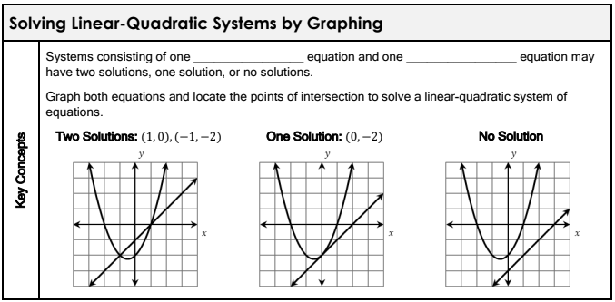

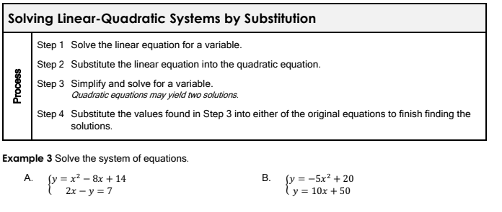

Word Problem Examples:

1. A ball is thrown upward from the top of a 40-foot-high building. The ball’s height, h (in feet), above the ground after t seconds is given by the equation $h=-16t^{2}+64t+40$.
When does the ball reach its maximum height?
What is the maximum height the ball reaches?

2. The dimensions of a square are altered so that 5 cm is added to one side and 2 cm is subtracted from the other. The area of the resulting rectangle is 84 ${cm}^{2}$. What was the original side length of the square?

3. A rectangular garden is 10 m long and 7 m wide. A uniform border of flowers is planted around the garden. If the total area of garden plus the border is 120 $m^{2}$,how wide is the border?

4. The product of two consecutive positive even integers is 120. Find the two integers.

Extras if needed!!!

